Bansilal Ramnath Agarwal Charitable Trust’s

Vishwakarma Institute of Technology, Pune-37
(An autonomous Institute of Savitribai Phule Pune University)


Department of Multidisciplinary Engineering

Division | AIML-A
Batch | 01
GR No. | 12414243
Roll No. | 08
Name | Abhishek Anil Patil

Title:
- Natural join
- Theta join
- Equi join
- Left outer
- Right outer
- Fall outer union
- Self join

Description: In this assignment, we applied different SQL joins on the Exercises and Available_Equipments tables of our workout planner database. We used Natural Join to automatically match common columns, Theta Join with conditions, and Equi Join for equality-based matching. We also performed Left Outer, Right Outer, and Full Outer Joins to include unmatched rows from one or both tables. Lastly, a Self Join was used on the Exercises table to compare records within the same table. This helped us understand how joins combine data from multiple tables to extract meaningful results.

Screenshots/Output:

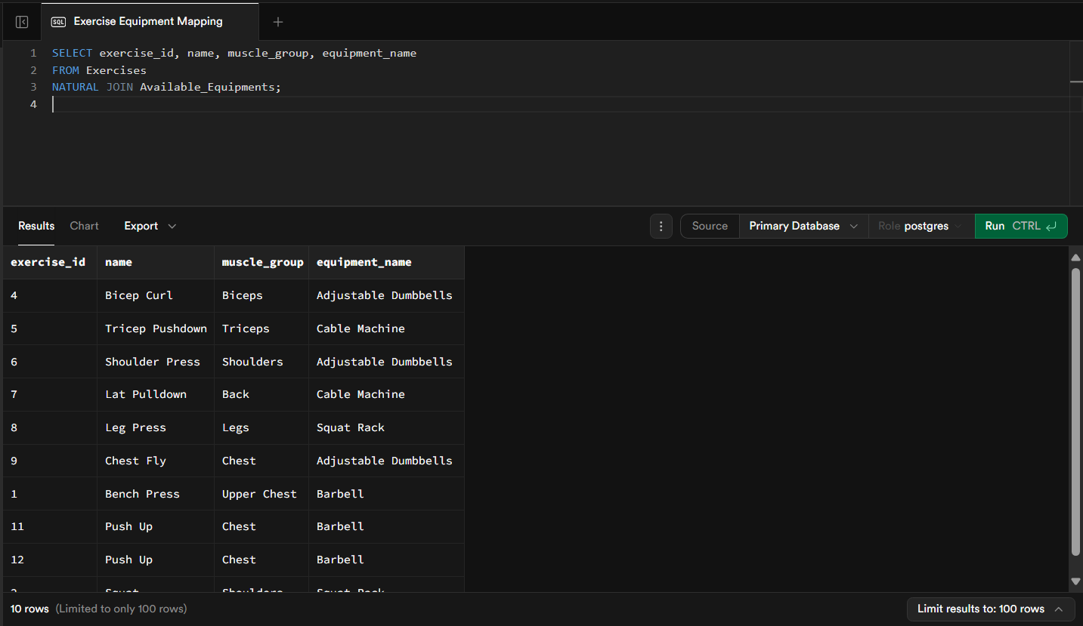
1)

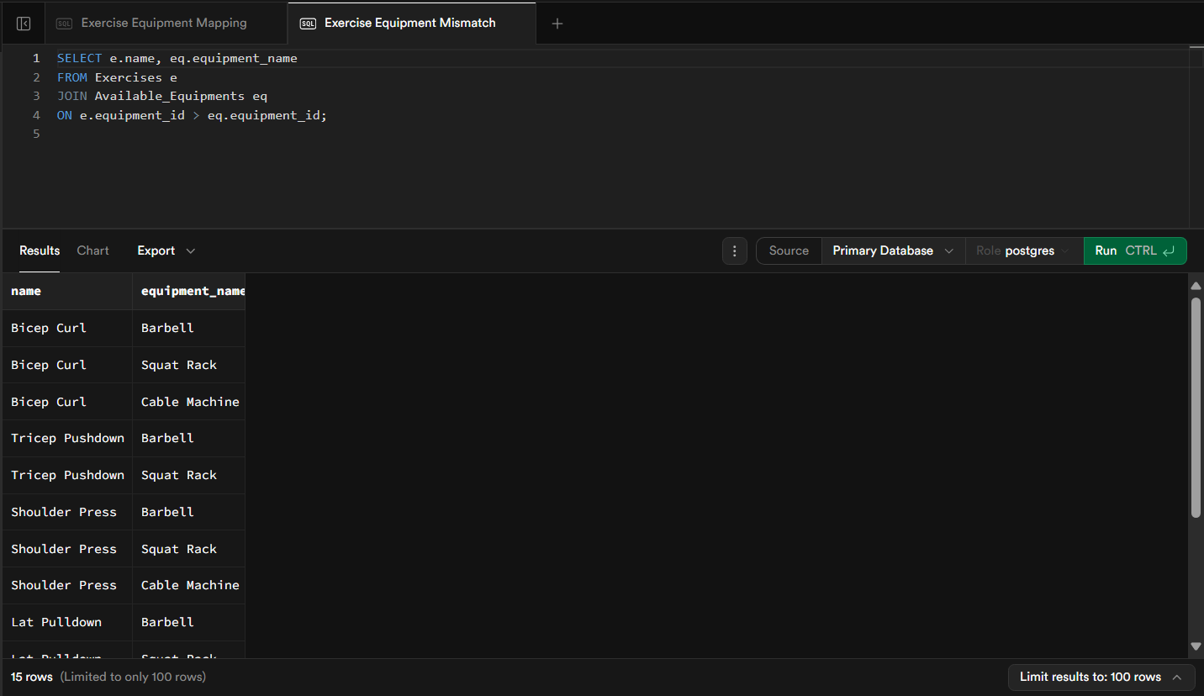
2)

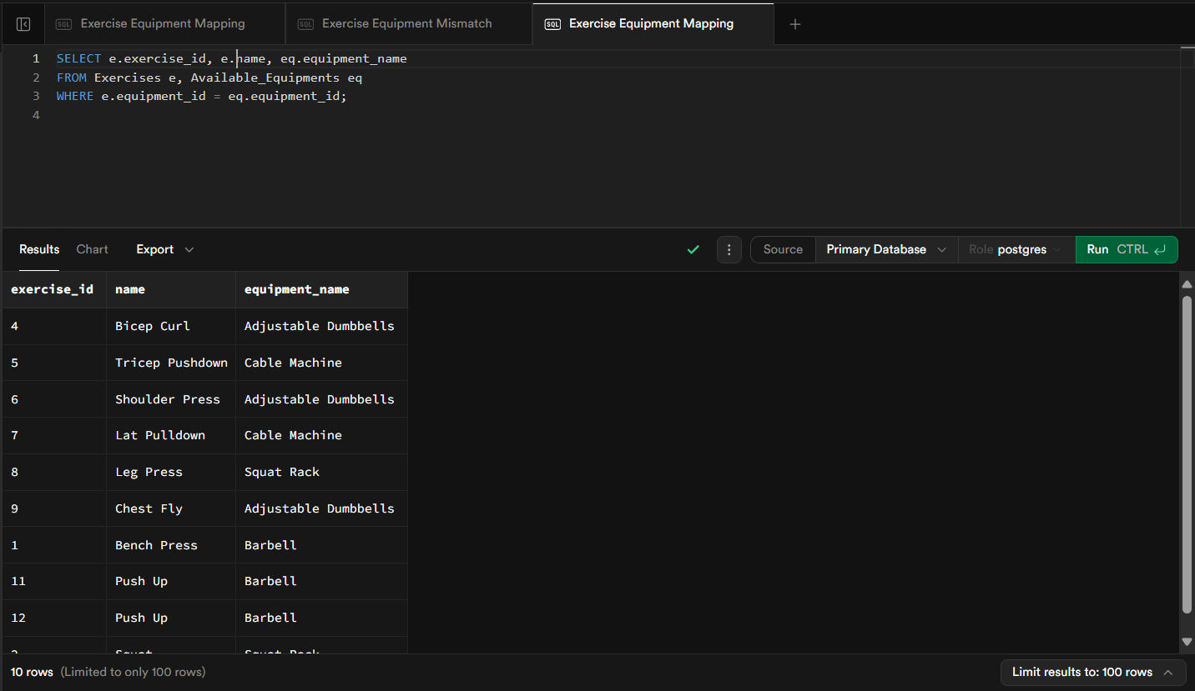
3)

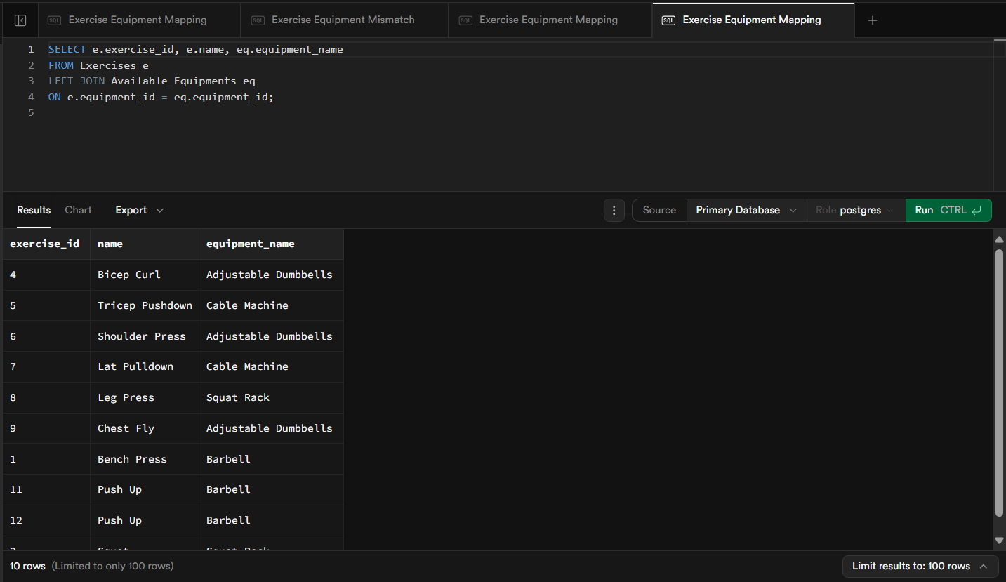
4)

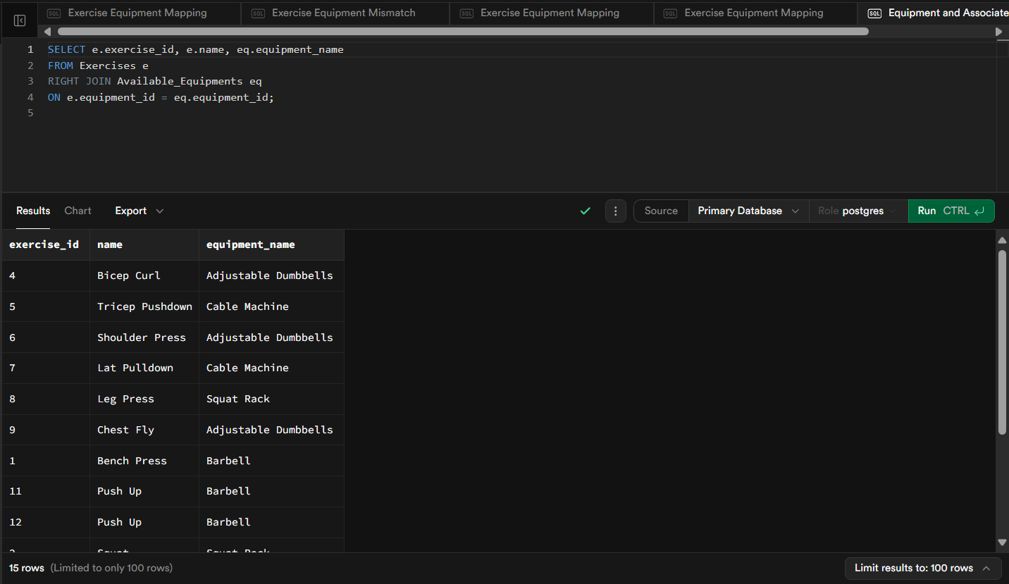
5)

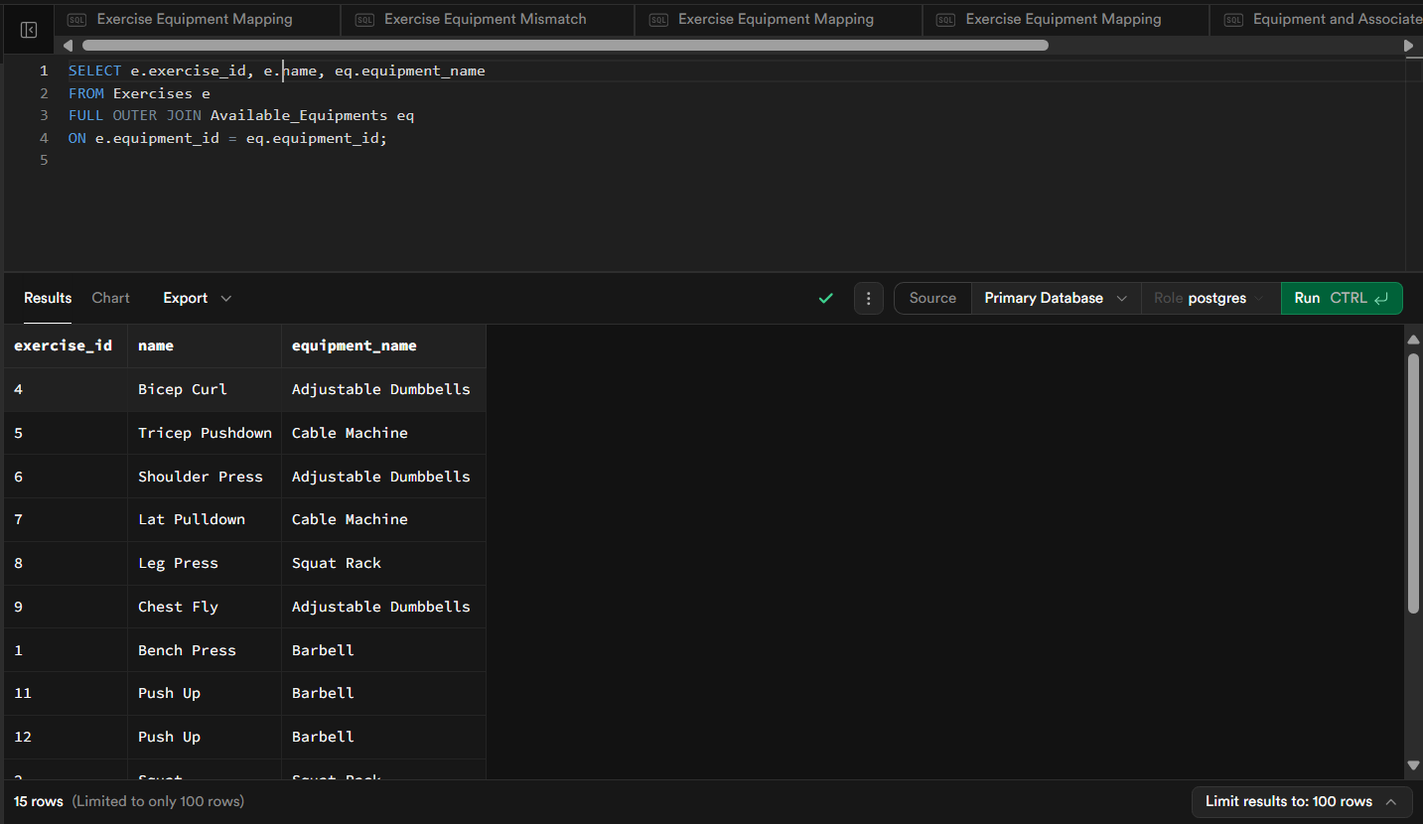
6)

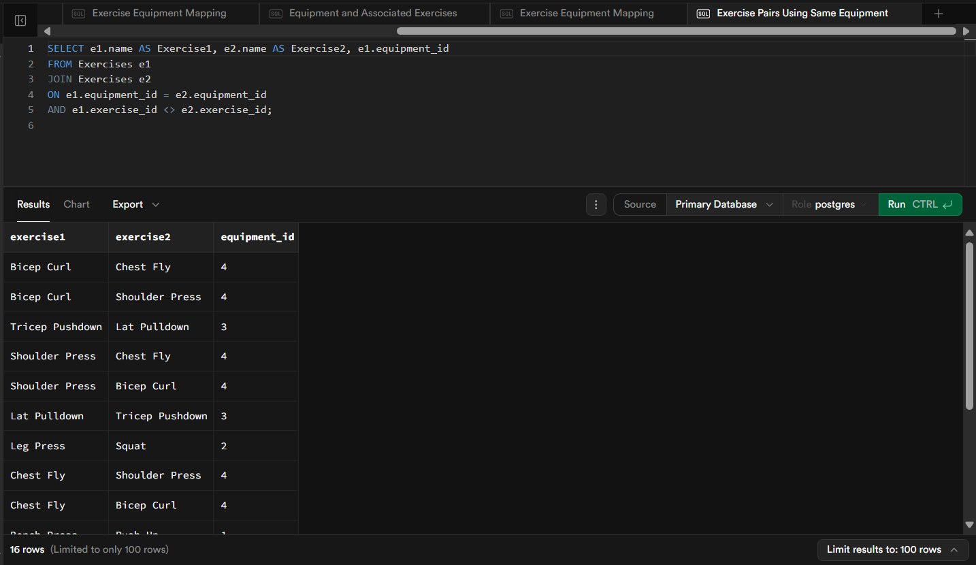
7)

